Lesson 4

Dimmer Switch

Activity Worksheet

**Dimmer Switch Activity**

In this activity you will expand the use of the potentiometer using it to control the brightness of the onboard LED. Learning how a dimmer switch works.   
**Note** if you are using the Pico W you will need an external LED. See the separate handout on wiring this to the breadboard.  
  
You have already learnt that LED’s are controlled using digitaloutput and an LED is either on or off. **However,** sometimes you want to be able to control an output to give more options than simply on and off. You may want to dim your lights or control a robot's speed, or the power level on a fan. To do this we can use pulse width modulation.

**What is PWM?**

**PWM** stands for **P**ulse **W**idth **M**odulation. It's a type of digital signal where, over a set period of time, the signal can be turned on and off incredibly fast.

This *very* *fast* ON/OFF signal can create a fading effect for LEDs.

**What is PWM Duty Cycle?**

We can decide how long we keep our LEDs ON/HIGH by changing the **Duty Cycle**. The duty cycle is the percentage of the time that our LED will be ON. The higher the duty cycle, the longer the LED will be ON, and the brighter our LED will appear.

Duty cycle for the Pico in MicroPython can range from **0 to 65535**, which is handy as this matches the output of our potentiometer (**0-65535**) so we can use this value directly without having to manipulate it.

**What is PWM Frequency?**

Our PWM code also needs a frequency value, which is the number of times per second that we will repeat the ON/OFF cycle.

**The dimmer switch Code**





**while True:**

led.duty_u16(adc.read_u16())This line enters an infinite loop that continuously reads the analog value from the potentiometer and sets the duty cycle of the PWM output to the read value. The duty cycle is a percentage of the time that the PWM output is high, which determines the brightness of the LED.

**Challenge 2 Set up a second potentiometer for next week’s activity to PIN 9 or ADC0**

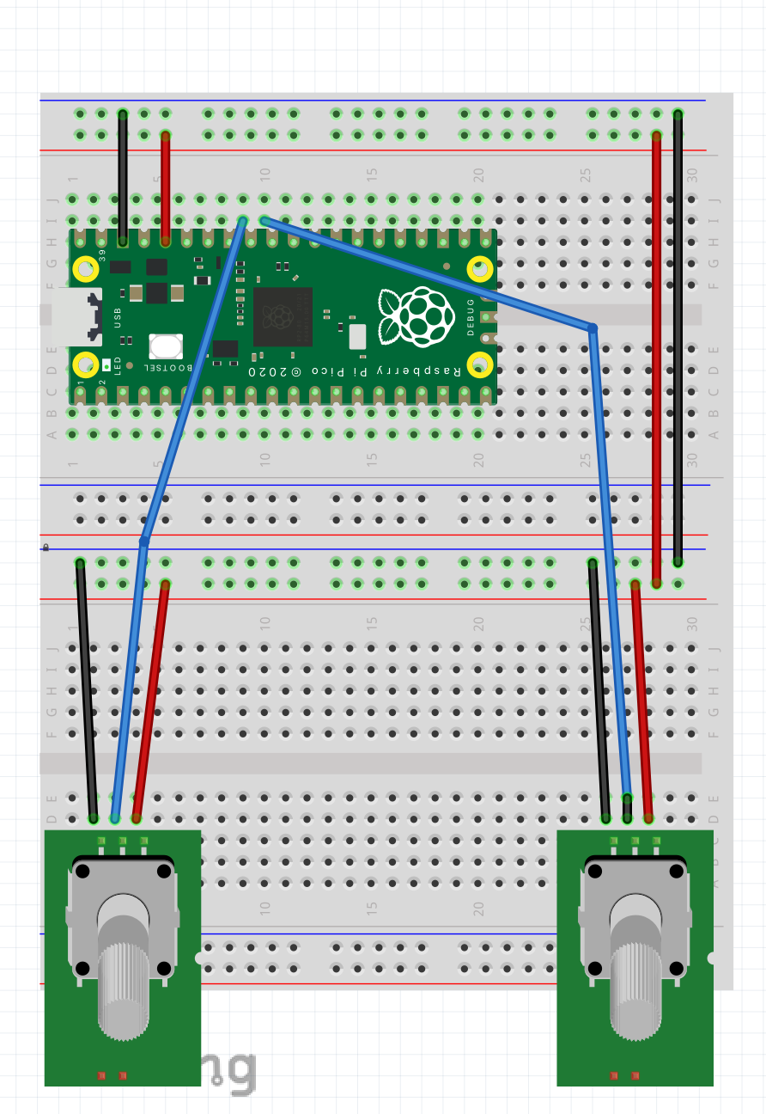

**Challenge 3 Create a flashing light that is controlled by the POT**

In this activity you will create a flashing light that is controlled by the pot reading. The reading is divided by 65000 to give an approximate 1 second maximum delay between the flashes.

Run your code and have fun experimenting with the flashing LED.

**Plenary:** in your own words, answer the following questions

**Explain the purpose of an analogue to digital convertor?**

**Explain the term PWM**